### **Experiment 9: Exploration of Prompting Techniques for Video Generation**

### **Aim:**

To explore and understand the various prompting techniques used for generating videos through AI models. The goal is to demonstrate how different prompt structures, such as simple vs. detailed prompts, affect the quality, coherence, and style of the generated videos.

### **Procedure:**

1. **Familiarize Yourself with Video Generation Models:**
   * Begin by exploring AI tools capable of video generation from text prompts. Popular models for video generation include:
     + **Runway Gen-2**
     + **Synthesia**
     + **Pictory**
     + **DeepBrain**
   * Understand the capabilities and limitations of each tool before starting the experiment.
2. **Create Simple Prompts for Video Generation:**
   * Start with simple prompts to generate short videos. These prompts should describe the general subject or activity.
   * Example prompt: "A person walking in a park."
3. **Experiment with More Detailed Prompts:**
   * Gradually refine your prompts by adding specific details, such as the setting, lighting, actions, or expressions.
   * Example prompt: "A person in a red jacket walking along a sunny park path, with birds flying in the sky, and a dog running beside them."
4. **Add Time and Motion Elements:**
   * Incorporate aspects like timing, transitions, or camera movement in your prompts.
   * Example prompt: "A time-lapse video of the sun setting over the ocean, with the camera slowly zooming out from a beach, capturing the waves and changing colors in the sky."
5. **Test Different Video Styles:**
   * Experiment with different styles of video generation, such as animations, live-action, cinematic, or artistic.
   * Example prompt: "An animated scene of a futuristic city at night, with glowing neon lights, flying cars, and a bustling crowd of people."
6. **Iterate and Adjust Prompts:**
   * Evaluate the generated video and refine the prompt if needed. Consider aspects like the pacing, transitions, and consistency of motion in the video.
   * Example: After reviewing, refine the prompt to add more details about the camera angles or actions: "A cinematic shot of a car speeding through a neon-lit city at night, with reflections on the wet street and a high-speed chase scene."
7. **Generate Multiple Versions:**
   * Generate multiple versions of the same prompt with slight variations to compare how the video output differs based on the phrasing of the prompt.
8. **Save and Compare Outputs:**
   * Save different versions of the videos and compare the results to understand how different prompts produce varying styles, sequences, and video qualities.

### **Tools for Video Generation:**

* **Runway Gen-2**: A popular model for generating videos from text descriptions, known for producing high-quality video outputs.
  + Website: Runway Gen-2
* **Synthesia**: A platform for creating AI-generated videos with avatars and customizable scripts.
  + Website: [Synthesia](https://www.synthesia.io/)
* **Pictory**: A tool that helps in transforming text-based content (like articles or blog posts) into videos.
  + Website: [Pictory](https://pictory.ai/)
* **DeepBrain**: AI that can generate videos based on textual prompts, including lip-syncing and facial expressions.
  + Website: [DeepBrain](https://www.deepbrain.io/)

**Implementation:**

**Video Generation Tool:** Pictory

**Simple Prompt 1:** “Dog in the Park”

**Output:**

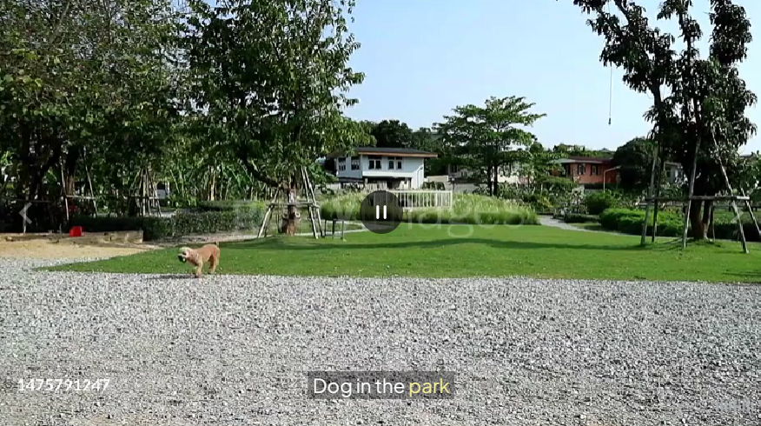

**Refined Prompt:** “A white dog playing with a ball in the park”

**Output:**

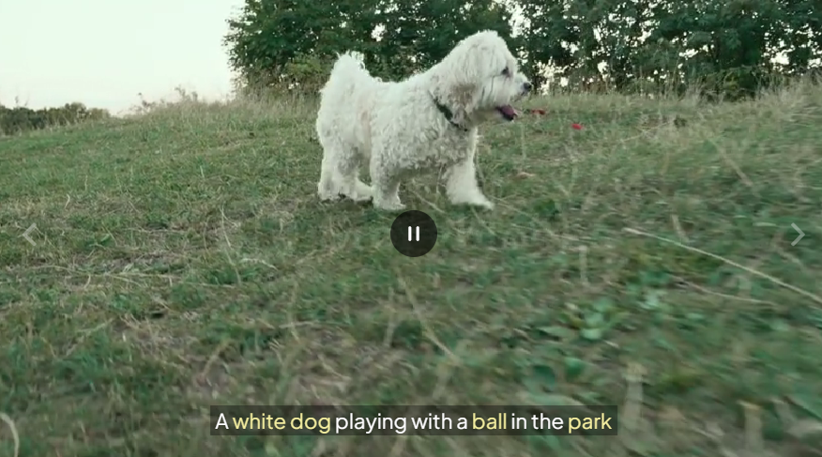

**Prompt with incorporated Motion and Transitions:** “A timelapse video of a dog near a tree, with camera zooming in on the dog”

**Output:**

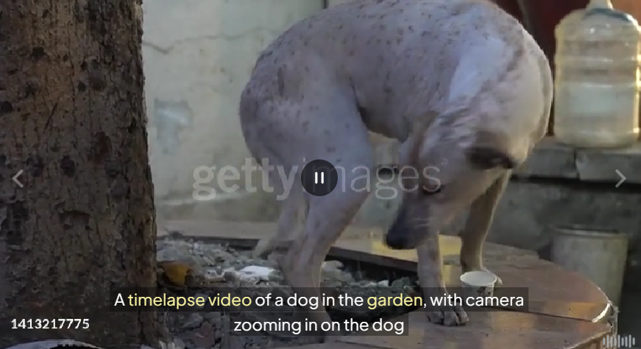

**Prompt with Different Style:** “Cartoon dogs in the park”

**Output:**

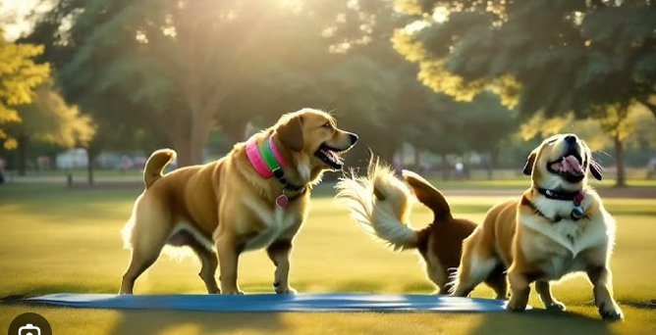

**Simple Prompt 2:** “Flower blooming”

**Output:**

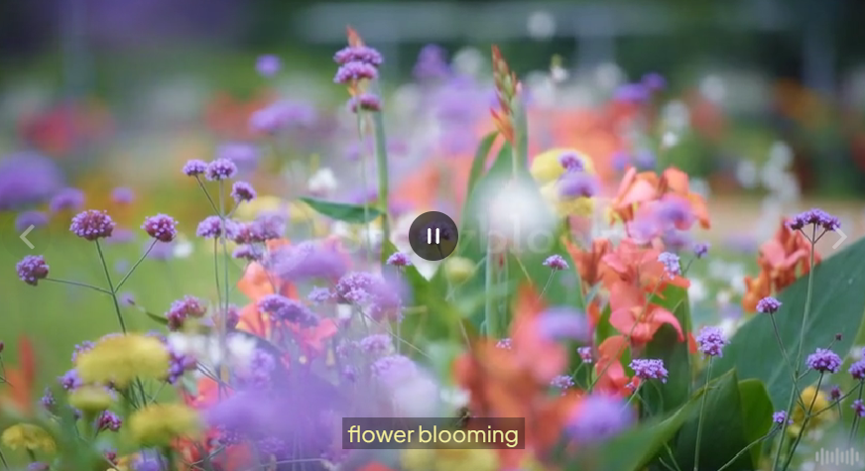

**Refined Prompt:** “Red flower blooming”

**Output:**

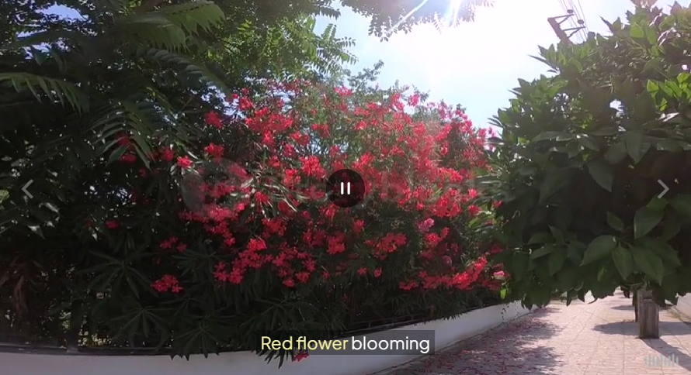

**Prompt with incorporated Motion and Transitions:** “A time-lapse video of a flower blooming in a garden, with the camera zooming in on them”

**Output:**

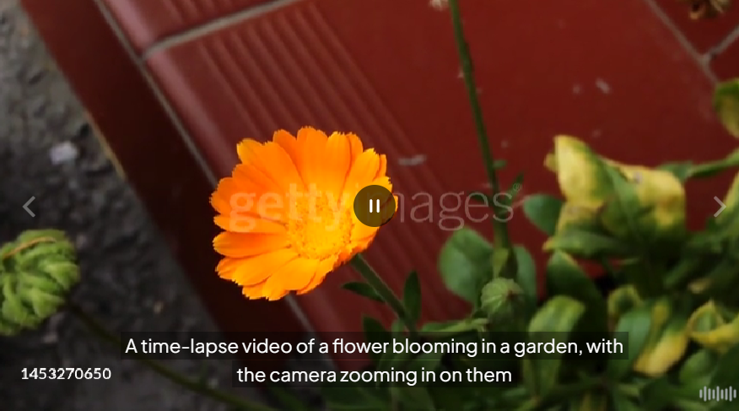

**Prompt with Different Style:** “A cartoon yellow flower”

**Output:**

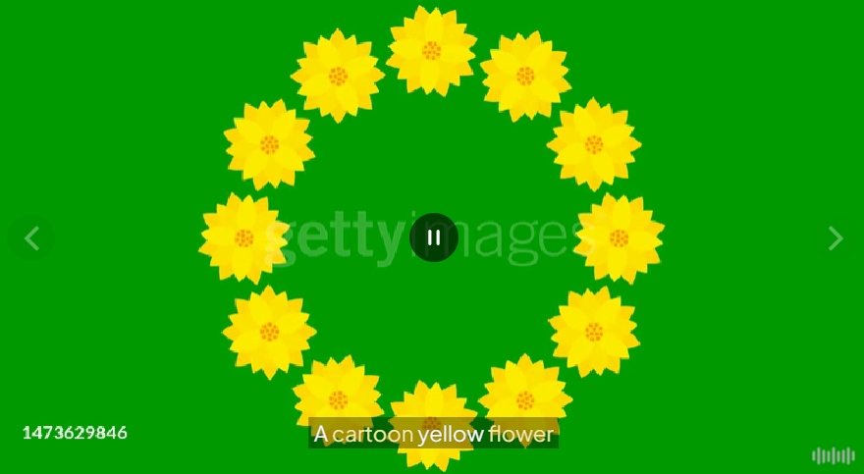

**Prompt Comparison:**

| Prompt Type | Prompt Example | Explanation of Differences |
| --- | --- | --- |

|  |  |  |
| --- | --- | --- |
| Simple Prompt | "Dog in the Park",  “Flower blooming” | This is a basic, broad prompt, offering only a general idea of the scene without specifying any particular details. It leaves much to the imagination and lacks context. |

|  |  |  |
| --- | --- | --- |
| Refined Prompt | "A white dog playing with a ball in the park",  “Red flower blooming” | This version is more specific, describing the dog's color and the activity (playing with a ball), making the scene clearer and more defined. |

|  |  |  |
| --- | --- | --- |
| Prompt with Incorporated Motion | "A timelapse video of a dog near a tree, with camera zooming in on the dog",  “A time-lapse video of a flower blooming in a garden, with the camera zooming in on them” | This prompt adds a dynamic element by including motion (timelapse and camera zoom) and setting a more specific environment (near a tree), creating a sense of action and focus. |

|  |  |  |
| --- | --- | --- |
| Prompt with Different Style | "Cartoon dogs in the park",  “A cartoon yellow flower” | By specifying a cartoon style, this prompt alters the artistic representation of the scene, making it less realistic and more playful or exaggerated in its visual approach. |